Python Enhancement Proposals (PEPs)

PEP-8 and PEP-257 are essential Python Enhancement Proposals (PEPs) that provide guidelines for writing Python code and docstrings. They help maintain consistency, readability, and standardization in Python projects.

PEP-8: Style Guide for Python Code

### 1. Code Layout

#### 1.1. Indentation

* Use 4 spaces per indentation level.
* Avoid using tabs for indentation.

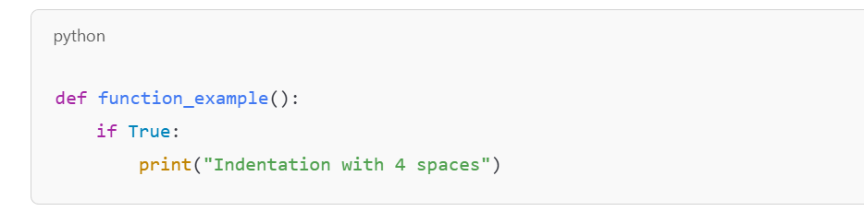

#### 1.2. Line Length

* Limit lines to 79 characters.
* For long lines, use parentheses, backslashes, or implied line continuations.

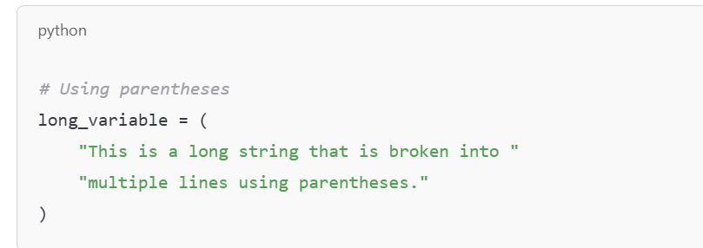

#### 

#### 1.3. Blank Lines

* Surround top-level functions and class definitions with two blank lines.
* Use one blank line to separate methods within a class.

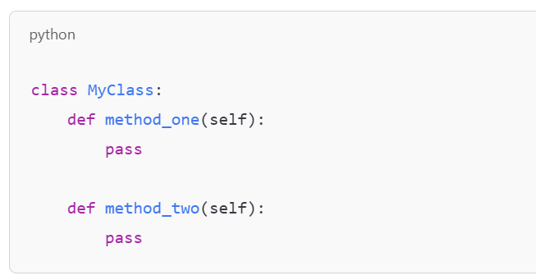

#### 1.4. Imports

* Imports should:
  + Be on separate lines.
  + Follow this order:
    1. Standard library imports
    2. Related third-party imports
    3. Local application/library imports

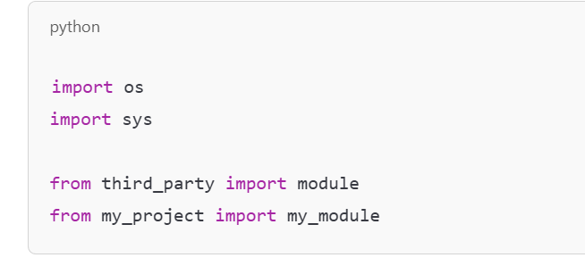

### 2. Naming Conventions

#### 2.1. Variables and Functions

* Use snake_case for variables and functions.

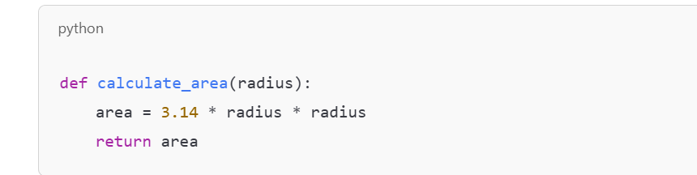

#### 2.2. Classes

* Use CamelCase for class names.

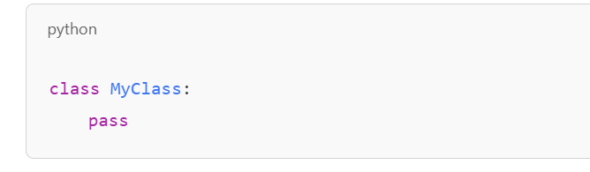

#### 2.3. Constants

* Use UPPER_CASE for constants.

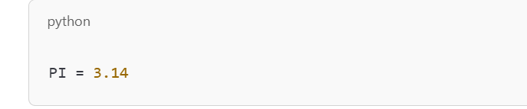

### 3. String Quotes

* Use single (') or double (") quotes consistently.

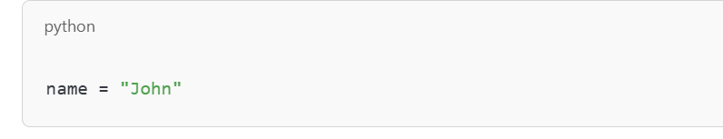

### 4. Whitespace

* Avoid extra spaces around operators and brackets.

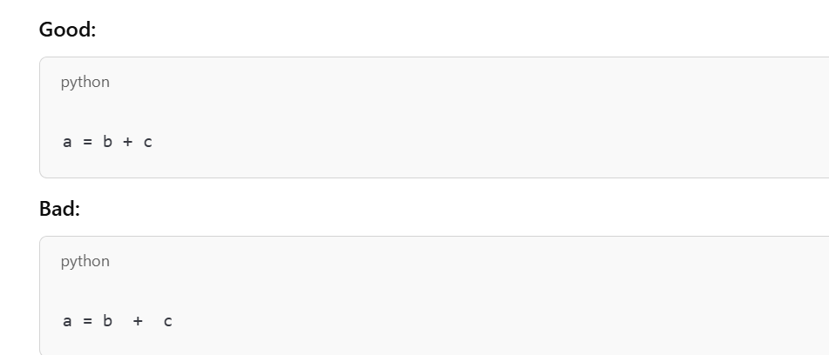

### 5. Comments

* Use comments sparingly and keep them concise.

#### 5.1. Block Comments

* Explain the logic or purpose of the code.

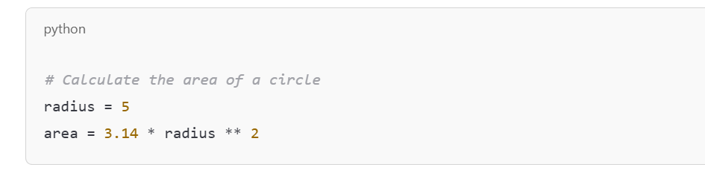

#### 5.2. Inline Comments

* Use inline comments sparingly and add at least two spaces before the #.

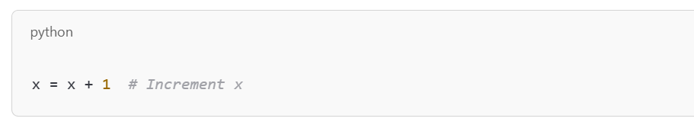

### 6. Avoid Trailing Whitespace

Remove any unnecessary whitespace at the end of a line.

PEP-257: Docstring Conventions

### 1. General Guidelines

* Use triple double quotes (""") for docstrings.
* All public modules, functions, classes, and methods should have docstrings.

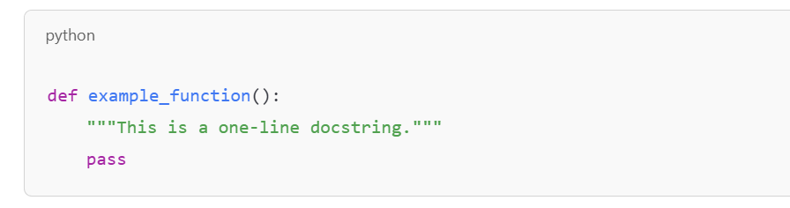

### 2. Module Docstrings

* Describe the module's purpose and contents.

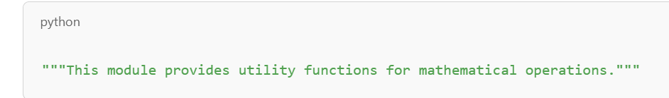

### 3. Function and Method Docstrings

* Include a brief description, arguments, return value, and exceptions (if applicable).

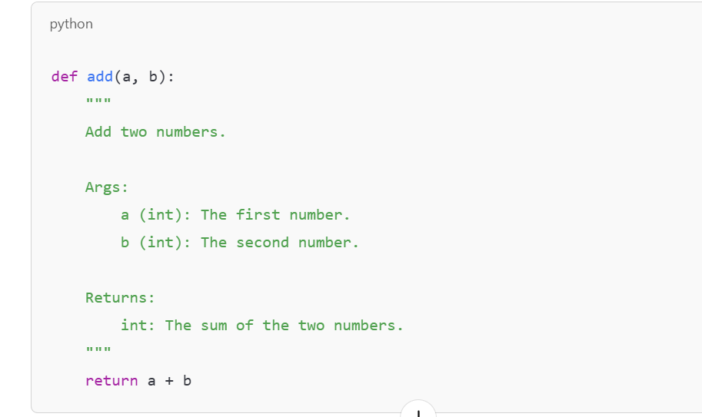

### 4. Class Docstrings

* Describe the purpose of the class and its methods.

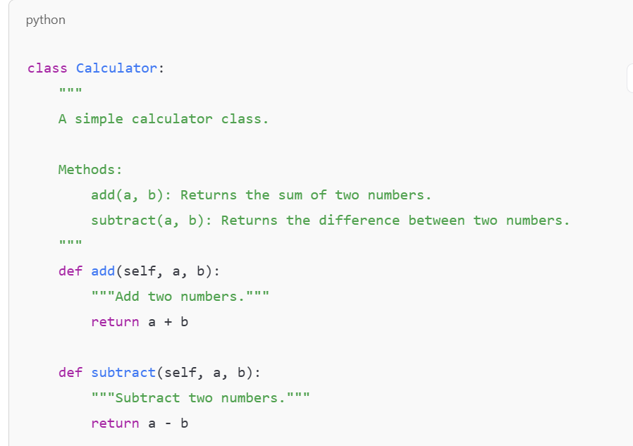

### 5. Multi-Line Docstrings

* Use a one-line summary followed by a blank line and detailed description.

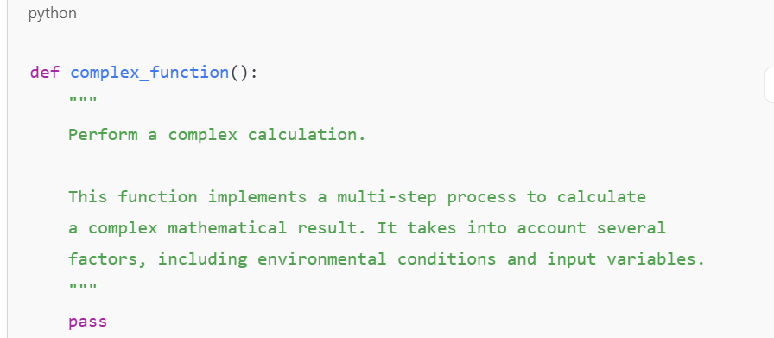

References

* [*https://peps.python.org/pep-0008/*](https://peps.python.org/pep-0008/)
* *https://peps.python.org/pep-0257/*